Business Requirements Document(BRD) Template
Project/Initiative
Month 20YY
Version X.XX

Company Information

Document Revisions
Date | Version Number | Document Changes
05/02/20xx | 0.1 | Initial Draft

Approvals
Role | Name | Title | Signature | Date
Business Owner
End Users
User Experience Lead
Development Lead
Quality Lead
Project Manager

Introduction

Project Summary

Objectives
To increase hotel bookings on TravelMate from 70% to 90% in 6 months after the release, by adding new wishlist folders and a hotel comparison table.

Background
Currently, TravelMate users can save hotels to one general Wishlist. However, users often plan different trips in advance, such as "Vacation 2026", "Business Trip", or "Weekend in Odesa". It is very important for them to create separate folders for different trips.
The new feature will allow users to create folders inside the Wishlist and compare hotels by key factors (like price, breakfast, and location). This will make the travel experience better and help users choose the best hotel faster.

Business Drivers
[List the business drivers that make development of this product important. These can be financial, operational, market or environmental.]

Project Scope
Description: Creation of personalized folders in the Wishlist that allow users to compare selected hotels by specific criteria.

In Scope Functionality
- Folder Creation in Wishlist: The user can create, name, and delete folders.
- Comparison Table: The user can compare 2 to 5 hotels on one screen using chosen criteria.
- Key Parameters: The user can see parameters such as "Distance to the sea/center", "Breakfast availability", and "Total price".
- Highlight Differences: The system highlights the differences between the hotels.
- Price Notifications: The system sends an automatic push-notification to the user when the price of a selected hotel changes.
- Low Availability Notifications: The system sends an automatic push-notification to the user if the number of free rooms in a selected hotel is less than 10.
- Folder Sharing: The user can share Wishlist folders with friends or family.
- Cross-device Sync: A list created on a PC is available in the mobile app (cloud synchronization).
- Folder Saving: The user can add hotels to a "temporary wishlist" (via cookies). However, to save the list forever and access it from different devices, the user must log in (authorize).
- Authorization for Saving: The user can register and log in to save wishlist folders permanently and synchronize them across devices.

Out of Scope Functionality
- Users cannot edit the same wishlist folder together in real time.
2. Users cannot create their own comparison criteria.
3. Deleted folders cannot be restored.
4. Hotels with missing data will show empty fields in the comparison table; the system will not estimate or generate missing values.
5. Users cannot see price history for a hotel.
6. Users cannot add notes or comments to hotels in a wishlist.

System Perspective
[Provide a complete description of the factors that could prevent successful implementation or accelerate the projects, particularly factors related to legal and regulatory compliance, existing technical or operational limitations in the environment, and budget/resource constraints.]

Assumptions

Constraints

Risks

- .

Issues

Business Process Overview
[Describe how the current process(es) work, including the interactions between systems and various business units. Include visual process flow diagrams to further illustrate the processes the new product will replace or enhance.
Use case documentation and accompanying activity or process flow diagrams can be used to create the description(s) of the proposed or “To-Be” processes.]

Current Business Process (As-Is)
At any point during or after deployment of web apps or web sites (internal or external) to support business activities, development/support teams may create and deploy widgets.
- CMS / database administrators for the employee portal use the CMS tool to create widgets. They can test widgets in the designated staging environment, then register them and deploy to production.
- Development teams may deploy widgets to development and testing environments set up for their development projects. They must check widget code into and out of the source code repository according to their projects’ development schedule.
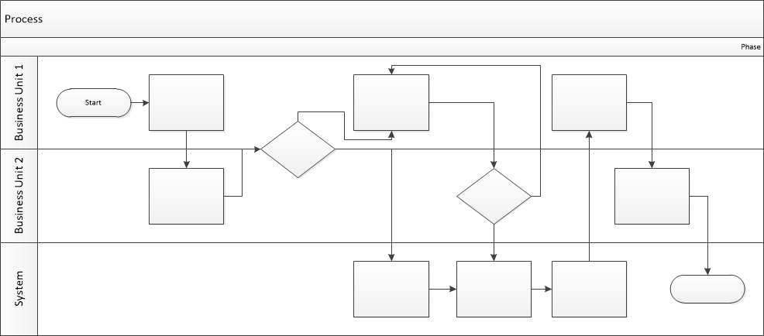

Proposed Business Process (To-Be)
- Technical Lead searches repository
- If widget is not found, user creates a new widget name record.
- WINS validates that all fields have been completed.
- WINS confirms that no similar widgets exist
- User confirms record to be created.

- User searches repository to locate existing widget description.
- WINS displays record
- User selects Edit to open and modify record
- WINS validates all fields completed correctly
- User confirms changes.
- WINS confirms changes and updates Audit table.


Stakeholder Requirements
The requirements below were collected from users and the business owner. They are grouped by function and priority to make them easier to read and understand.
The requirements in this document are prioritized as follows:
Value | Rating | Description
1 | Critical | This requirement is critical to the success of the project. The project will not be possible without this requirement.
2 | High | This requirement is high priority, but the project can be implemented at a bare minimum without this requirement.
3 | Medium | This requirement is somewhat important, as it provides some value but the project can proceed without it.
4 | Low | This is a low priority requirement, or a “nice to have” feature, if time and cost allow it.
5 | Future | This requirement is out of scope for this project, and has been included here for a possible future release.

Functional Requirements
Req# | Priority | Description | Rationale | Use Case Reference | Impacted Stakeholders
General / Base Functionality
FR-G-001 | 1 | Folder Creation: The system must allow the user to create a new folder inside the Wishlist. | Users often plan different trips at the same time. Folders help them organize saved hotels and find them more easily later. |  | End Users
FR-G-002 | 1 | Folder Naming: The system must allow the user to name and edit the name of the folder. | Users can organize their saved hotels by trip type or destination, making the Wishlist easier to use. |  | End Users
FR-G-003 | 1 | Adding a Hotel: The system must allow the user to add a specific hotel to the chosen folder. | Users can keep hotels they like in one place and view them later. |  | End Users
FR-G-004 |  | Comparison Screen: The system must show the parameters of the chosen hotels side-by-side on one screen (in a table/matrix layout). | Users can easily compare hotels and choose the best option for their needs. |  | End Users
FR-G-005 |  | Price Display: The system must show the "Total price" for each hotel in the table. | Users can quickly compare hotel prices and make better booking decisions. |  | End Users
FR-G-006 |  | Location Display: The system must show the "Distance to the sea/center" for each hotel in the table. | Distance helps users choose a hotel with a convenient location for their trip. |  | End Users
FR-G-007 |  | Conditions Display: The system must show "Breakfast availability" for each hotel in the table. | Users can compare hotel services and choose the option that best meets their needs. |  | End Users
FR-G-008 |  | Highlight Differences: The system must have a feature (a button or a switch) to visually highlight the parameters that are different between the hotels. | Users can quickly see the differences between hotels and make a decision more easily. |  | End Users
FR-G-009 |  | Price Drop Trigger: The system must automatically send a notification to the user if the price of a hotel in their Wishlist drops (or drops by 10%+ for marketing reasons). | Users can save money and book hotels at a better price.  Price drop notifications encourage users to return to the platform and increase the chance of completing a booking. |  | End Users  Marketing Lead
FR-G-0010 |  | Low Availability Trigger: The system must send a notification if the number of available rooms in a saved hotel becomes critically low (less than 10 rooms). | Users can act quickly before the hotel becomes unavailable  Low availability notifications create urgency and encourage users to complete a booking sooner.. |  | End Users  Marketing Lead
FR-G-0011 |  | Authorization for Saving: The system must provide a registration and login feature to save wishlist folders permanently and sync them across devices. | Users can save their wishlist permanently and use it on both desktop and mobile devices. |  | Business Owner
FR-G-0012 |  | Folder Sharing: The user can share a Wishlist folder with other people. They can see the saved hotels in the folder. | Users need a simple way to share saved hotels with friends and family when planning a trip together.  This feature helps more people use the platform. Users can share hotel lists with friends and family, which can bring new users and increase activity in the app. |  | End Users  Marketing Lead
 |  | Description: The user can remove a Wishlist folder that is no longer needed. | Users need a way to keep their Wishlist organized by removing old or unused folders. |  | End Users
Security Requirements
FR-S-001 | 1
Reporting Requirements
FR-R-001 | 2
Usability Requirements
FR-U-001 | 1 | If the comparison table is larger than the screen, the user must be able to scroll horizontally to see all hotels. | Horizontal scrolling ensures that all comparison information remains accessible on different screen sizes. |  | End Users
Audit Requirements
FR-A-001 | 1

Non-Functional Requirements
[Include technical and operational requirements that are not specific to a function. This typically includes requirements such as processing time, concurrent users, availability, etc.]
ID | Requirement
NFR-001 | Notifications about price drops and low availability must be delivered without duplicate messages.
NFR-002 | The system must display empty cells for missing hotel attributes rather than errors.
NFR-003 | User passwords must be stored in an encrypted form.
NFR-004 | The comparison table must be accessible on screen widths from 320 px to 1920 px.
NFR-005 | When a guest user closes the browser or is inactive for more than 30 minutes, all guest session data must be deleted and must not be available after reopening the website.

Appendices

List of Acronyms
[If needed, create a list of acronyms used throughout the BRD document to aid in comprehension.]

Glossary of Terms
[If needed, identify and define any terms that may be unfamiliar to readers, including terms that are unique to the organization, the technology to be employed, or the standards in use.]

Related Documents
[Provide a list of documents or web pages, including links, which are referenced in the BRD.]

